LIGHT SENSOR USING PHOTODIODE

The project about light sensor circuit shows the application of photodiode to detect the presence of light. This light sensor can be used as an intermediate circuit in various applications to detect the presence or absence of light. The sensitivity of the sensor can be adjusted using the preset.

DESCRIPTION:

A photodiode, used as a photo detector, generates current in the circuit when light incidents on it. The circuit of this project uses the photodiode in reverse bias mode with resistor R1(10k). This resistor does not allow too much current to flow through the photodiode in case a large amount of light falls on the detector. Initially when no light falls on the photodiode, it results in high potential at the inverting input of a comparator (pin6) of LM339. When light falls on the photodiode, it allows current to flow through the diode, and thus drops the voltage across it. The non-inverting input (pin7) is connected to a variable resistor VR2 (preset) which is used to set the reference voltage of the comparator. A comparator works on the principle that its output remains high as long as the non-inverting input is at higher level than that at its inverting input. Here, the output (pin1) is connected to an LED. The reference voltage is set to correspond to a threshold illumination through a preset VR1 (10k).

BLOCK DIAGRAM:

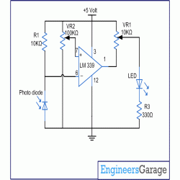

The LED at the output will glow when light falls on the diode. In such a condition, the inverting input drops to a lower value than the reference set at the non-inverting input and so the output goes providing the necessary forwards bias to the LED.